Chapter 5 :- User and Group Administration

Search in Dash:
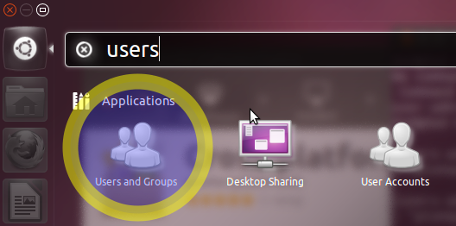

Click and it will run the Users and Groups applet:

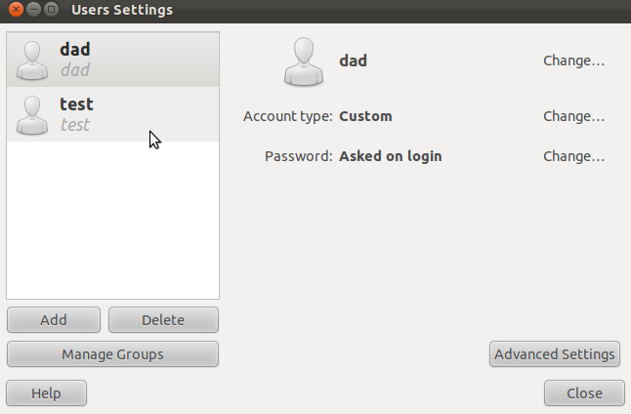

Adding and Deleting Users using command

The process for managing local users and groups is straightforward and differs very little from most other GNU/Linux operating systems. Ubuntu and other Debian based distributions encourage the use of the "adduser" package for account management.
- To add a user account, use the following syntax, and follow the prompts to give the account a password and identifiable characteristics, such as a full name, phone number, etc.
# sudo adduser username
- To delete a user account and its primary group, use the following syntax:
# sudo deluser username
Deleting an account does not remove their respective home folder. It is up to you whether or not you wish to delete the folder manually or keep it according to your desired retention policies.
Remember, any user added later on with the same UID/GID as the previous owner will now have access to this folder if you have not taken the necessary precautions.
You may want to change these UID/GID values to something more appropriate, such as the root account, and perhaps even relocate the folder to avoid future conflicts:
# sudo chown -R root:root /home/username/
# sudo mkdir /home/archived_users/
# sudo mv /home/username /home/archived_users/
- To temporarily lock or unlock a user account, use the following syntax, respectively:
# sudo passwd -l username
# sudo passwd -u username
- To add or delete a personalized group, use the following syntax, respectively:
# sudo addgroup groupname
# sudo delgroup groupname
- To add a user to a group, use the following syntax:
# sudo adduser username groupname

User Profile Security
When a new user is created, the adduser utility creates a brand new home directory named /home/username. The default profile is modeled after the contents found in the directory of /etc/skel, which includes all profile basics.
If your server will be home to multiple users, you should pay close attention to the user home directory permissions to ensure confidentiality. By default, user home directories in Ubuntu are created with world read/execute permissions. This means that all users can browse and access the contents of other users home directories. This may not be suitable for your environment.
- To verify your current user home directory permissions, use the following syntax:
# ls -ld /home/username
The following output shows that the directory /home/username has world-readable permissions:
drwxr-xr-x 2 username username 4096 2007-10-02 20:03 username
- You can remove the world readable-permissions using the following syntax:
# sudo chmod 0750 /home/username
Some people tend to use the recursive option (-R) indiscriminately which modifies all child folders and files, but this is not necessary, and may yield other undesirable results. The parent directory alone is sufficient for preventing unauthorized access to anything below the parent.
A much more efficient approach to the matter would be to modify the adduser global default permissions when creating user home folders. Simply edit the file /etc/adduser.conf and modify the DIR_MODE variable to something appropriate, so that all new home directories will receive the correct permissions.
DIR_MODE=0750
- After correcting the directory permissions using any of the previously mentioned techniques, verify the results using the following syntax:
# ls -ld /home/username
The results below show that world-readable permissions have been removed:
drwxr-x--- 2 username username 4096 2007-10-02 20:03 username

Password Policy
A strong password policy is one of the most important aspects of your security posture. Many successful security breaches involve simple brute force and dictionary attacks against weak passwords. If you intend to offer any form of remote access involving your local password system, make sure you adequately address minimum password complexity requirements, maximum password lifetimes, and frequent audits of your authentication systems.

Minimum Password Length
By default, Ubuntu requires a minimum password length of 6 characters, as well as some basic entropy checks. These values are controlled in the file /etc/pam.d/common-password, which is outlined below.
password [success=1 default=ignore] pam_unix.so obscure sha512
If you would like to adjust the minimum length to 8 characters, change the appropriate variable to min=8. The modification is outlined below.
password [success=1 default=ignore] pam_unix.so obscure sha512 minlen=8
Basic password entropy checks and minimum length rules do not apply to the administrator using sudo level commands to setup a new user.

Password Expiration
When creating user accounts, you should make it a policy to have a minimum and maximum password age forcing users to change their passwords when they expire.
- To easily view the current status of a user account, use the following syntax:
# sudo chage -l username
The output below shows interesting facts about the user account, namely that there are no policies applied:
Last password change : Jan 20, 2015
Password expires : never
Password inactive : never
Account expires : never
Minimum number of days between password change : 0
Maximum number of days between password change : 99999
Number of days of warning before password expires : 7
- To set any of these values, simply use the following syntax, and follow the interactive prompts:

# sudo chage username

The following is also an example of how you can manually change the explicit expiration date (-E) to 01/31/2015, minimum password age (-m) of 5 days, maximum password age (-M) of 90 days, inactivity period (-I) of 5 days after password expiration, and a warning time period (-W) of 14 days before password expiration:
# sudo chage -E 01/31/2015 -m 5 -M 90 -I 30 -W 14 username
- To verify changes, use the same syntax as mentioned previously:
# sudo chage -l username
The output below shows the new policies that have been established for the account:
Last password change : Jan 20, 2015
Password expires : Apr 19, 2015
Password inactive : May 19, 2015
Account expires : Jan 31, 2015
Minimum number of days between password change : 5
Maximum number of days between password change : 90
Number of days of warning before password expires : 14

Some User Add Command

1. How to Add a New User in Linux
# useradd tecmint

2. Create a User with Different Home Directory
# useradd -d /data/projects anusha

3. Create a User with Specific User ID
# useradd -u 999 navin

4. Create a User with Specific Group ID
# useradd -u 1000 -g 500 tarunika

5. Add a User to Multiple Groups
# useradd -G admins,webadmin,developers tecmint

6. Add a User without Home Directory
# useradd -M shilpi

7. Create a User with Account Expiry Date
# useradd -e 2014-03-27 aparna

8. Create a User with Password Expiry Date
# useradd -e 2014-04-27 -f 45 tecmint

9. Add a User with Custom Comments
# useradd -c "Manis Khurana" mansi

10. Change User Login Shell:
# useradd -s /sbin/nologin tecmint

11. Add a User with Specific Home Directory, Default Shell and Custom Comment
# useradd -m -d /var/www/ravi -s /bin/bash -c "TecMint Owner" -U ravi

12. Add a User with Home Directory, Custom Shell, Custom Comment and UID/GID
# useradd -m -d /var/www/tarunika -s /bin/zsh -c "TecMint Technical Writer" -u 1000 -g 1000 tarunika

13. Add a User with Home Directory, No Shell, Custom Comment and User ID
# useradd -m -d /var/www/avishek -s /usr/sbin/nologin -c "TecMint Sr. Technical Writer" -u 1019 avishek

14. Add a User with Home Directory, Shell, Custom Skell/Comment
# useradd -m -d /var/www/navin -k /etc/custom.skell -s /bin/tcsh -c "No Active Member of TecMint" -u 1027 navin

15. Add a User without Home Directory, No Shell, No Group and Custom Comment
# useradd -M -N -r -s /bin/false -c "Disabled TecMint Member" clayton

Some User del Command

Example1: Delete user account from a machine
userdel username
Example:
userdel surendra

Example2: Deleting user account and his home directory from a Linux machine
userdel -r username
-r stands for remove home directory as well

Example3: Delete user account forcefully though user logged in.
deluser –force username

Example4: Delete user account along with his home directory
deluser –remove-home username

Example5: Delete user account along with his home directory and his personal files which are located in different locations which you are not aware.
deluser –remove-all-files username

Example6: Delete user account and take backup of his files to a directory for future use by the company.
deluser –backup-to DIR username

Example7: I want to delete user account Don and take backup of all his files to /var/backup
deluser –backup-to /var/backup don
Note: When you take backup, the backup file is created as /var/backup/don.tar.gz file.
Lets see in our next post on how to add user to primary group.

# usermod :- The usermod command modifies the system account files to reflect the
changes that are specified on the command line.

Adding and Deleting group using command

Groups allow system administrators to apply certain permissions or access to groups of users. It is sometimes necessary to remove a group from a system when it is no longer needed.
Before a group can be removed, any users assigned to the group should be reassigned to another group. To remove a group, you will use the groupdel command.

Syntax

1.Adding Group :

# groupadd <Groupname>

2.Adding with Option :

# groupadd <option> <GroupName>

Parameters or Arguments
The groupdel command requires the following parameter:
Group_Name
The name of the group you would like to remove. Group names should be entered in lowercase and may contain underscores.

Prerequisites
To complete this tutorial you will require a running Ubuntu Linux Server 14.04 LTS system and an account with sudo administrative privileges. The sudo command is used to provide the superuser privileges required for the groupdel command.

Remove a Group
The following steps will guide you through removing a group on an Ubuntu Linux Server 14.04 LTS system.
IMPORTANT: Certain pre-installed groups are required for the system to operate properly. Do NOT remove a group from a system unless you are sure it is not needed!
- To remove an existing group from your system, you will need to be logged in using a valid user account. If you are unsure of how to do this, read our tutorial on Logging into Ubuntu Linux Server 14.04 LTS.
In this tutorial, we have logged in as techonthenet on the host called ubuntu.
- Now that we're logged in, we can remove the group with a Group Name of students by entering the following groupdel command:
# sudo groupdel students
This screenshot demonstrates what you will see.
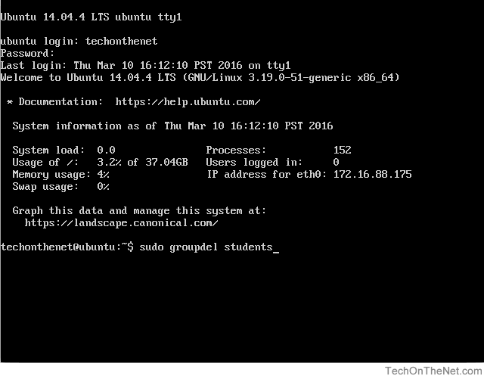
When you have typed in the command, press the Enter key to execute the command.
- The sudo command will now prompt you to enter the password for your administrator account.
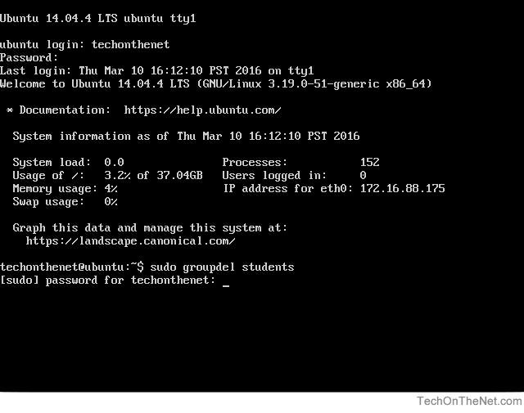
Please note that no characters will show as you type your password. This is normal and is important to preserve the security of your password.
After you have entered your password, press the Enter key to continue.
- If all goes well, you will see the system prompt appear again without any errors. This indicates that the group called students has been successfully removed.

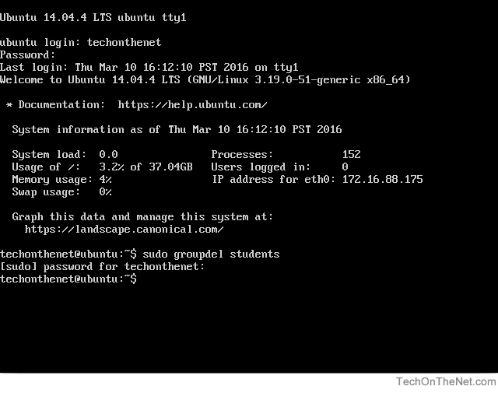
- This step and step #6 are optional.
In this step we will check to ensure that the group called students was removed from the system by using the grep command to search the system /etc/group file for the students group. If the students group is not found then we have confirmed that the group has been removed.
Enter the following grep command after the system prompt to search the system group file:
# sudo grep students /etc/group
The following screenshot demonstrates what the command will look like after it is typed.
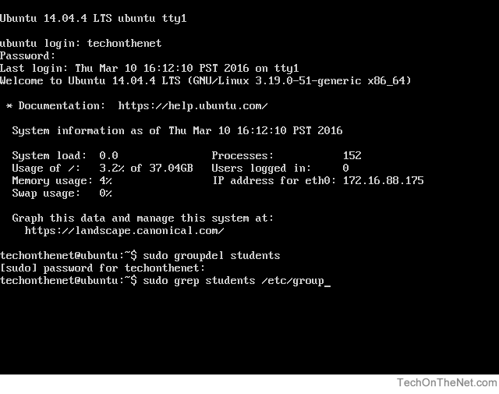
When you have typed the command, press the Enter key to execute the command.
- As seen in the screenshot below, the students group was not found by the grep command confirming that we have removed the students group from the system.
